**Learner Details**

* **Name:Nikhil k**
* **Enrollment Number: su625mr004**
* **Batch / Class: Mern Stack**
* **Assignment: Friends card**
* **Date of Submission: 29-07-2025**

**Problem Solving Activity 1.1**

**1. Program Statement**

To create a simple React application that displays a list of favorite people with their image, name, relation, and hobbies. The interface should be visually organized and responsive using basic inline CSS styling.

**2. Algorithm**

• Start the React app.

• Create a functional component App.

• Inside the component, define a layout with a heading and a container to hold profile cards.

• Use JSX to render multiple cards, each with:

* An image
* Name
* Relation
* Hobbies

• Use inline CSS to style the app with flex layout and card designs.

• Export the component and run the app in the browser.

**3. Pseudocode**

START

Create a component App:

Display heading "My Favourite People"

Create a flex container

For each person:

Display card with:

Image

Name

Relation

Hobbies

Apply inline CSS:

Flex container to wrap cards

Card design with border, padding, colors

END

**4. Program Code**

import React from 'react';

const App = () => {

return (

<div style={{ padding: '2rem', fontFamily: 'sans-serif', backgroundColor: '#8ac9ffff' }}>

<h1 style={{ textAlign: 'center', color: '#fff' }}>My Favourite People</h1>

<div style={{

display: 'flex',

flexWrap: 'wrap',

gap: '1.5rem',

justifyContent: 'center',

marginTop: '2rem'

}}>

<div style={cardStyle}>

<img src="https://randomuser.me/api/portraits/men/11.jpg" style={imgStyle} />

<h2>Aarav</h2>

<p><strong>Relation:</strong> Best Friend</p>

<p><strong>Hobbies:</strong></p>

<p>Gaming</p>

<p>Coding</p>

</div>

<div style={cardStyle}>

<img src="https://randomuser.me/api/portraits/women/21.jpg" style={imgStyle} />

<h2>Priya</h2>

<p><strong>Relation:</strong> Friend</p>

<p><strong>Hobbies:</strong></p>

<p>Reading</p>

<p>Music</p>

</div>

<div style={cardStyle}>

<img src="https://randomuser.me/api/portraits/women/30.jpg" style={imgStyle} />

<h2>Anjali</h2>

<p><strong>Relation:</strong> Friend</p>

<p><strong>Hobbies:</strong></p>

<p>Dancing</p>

<p>Cooking</p>

</div>

<div style={cardStyle}>

<img src="https://randomuser.me/api/portraits/men/40.jpg" style={imgStyle} />

<h2>Ravi</h2>

<p><strong>Relation:</strong> Friend</p>

<p><strong>Hobbies:</strong></p>

<p>Photography</p>

<p>Cycling</p>

</div>

<div style={cardStyle}>

<img src="https://randomuser.me/api/portraits/women/44.jpg" style={imgStyle} />

<h2>Meena</h2>

<p><strong>Relation:</strong> Friend</p>

<p><strong>Hobbies:</strong></p>

<p>Yoga</p>

<p>Gardening</p>

</div>

</div>

</div>

);

};

const cardStyle = {

border: '5px solid #000',

borderRadius: '2px',

padding: '1rem',

width: '232px',

backgroundColor: '#ffe589ff',

color: '#000',

textAlign: 'center'

};

const imgStyle = {

width: '90%',

height: '200px',

objectFit: 'cover',

borderRadius: '6px',

marginBottom: '1rem'

};

export default App;

**5. Test Cases**

| **Test Scenario** | **Expected Output** |
| --- | --- |
| **App loads in browser** | **Heading and all cards visible** |
| **Card layout** | **Cards appear in rows and wrap on screen** |
| **Responsive design** | **Cards adjust properly on screen resize** |
| **Images & data display correctly** | **Each person has correct photo and text** |

**6. Screenshots of Output**

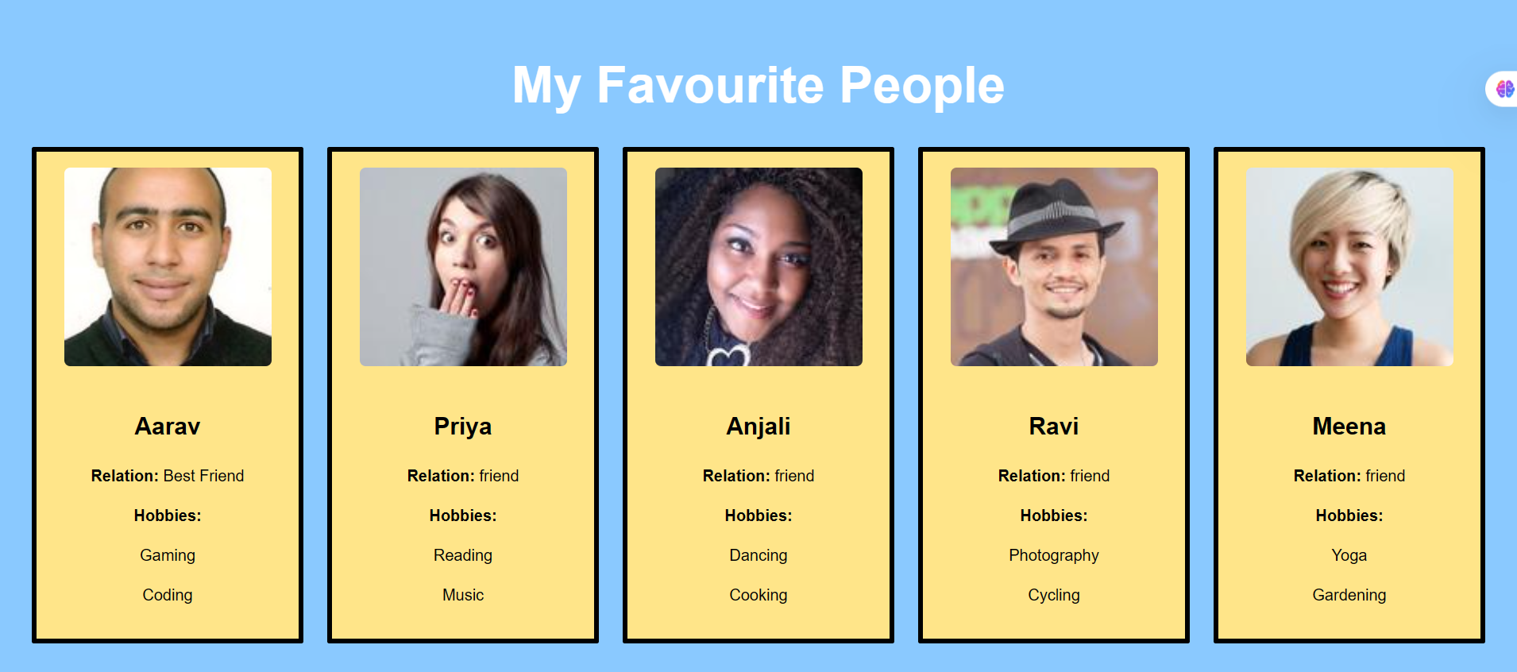

**7. Observation / Reflection**

• This project helped understand how to use JSX and inline styles in React.

• Practiced rendering repeated UI elements using component structure.

• The layout was easy to manage using flexbox styling.

• Next time, this can be improved using Tailwind or separate CSS files for better scalability.

**Problem Solving Activity 1.2**

**Follow the same Structure as problem Solving Activity 1.1.**